**Dear Colleagues:**

**Please, read this explanation carefully first, before filling in the case form.**

**Important:**

**The case should be a severe problem/illness, well documented by high quality diagnostics, that has been cured by only homeopathic treatment. The cure has to be proven by high quality diagnostics to withstand critical inspection.**

**The case has to fulfill at least 1 of the following criteria:**

1. **very doubtful prognosis for life or recovery, or was proposed to be euthanized because of incurability**
2. **had been treated without success with high quality conventional medicine**

Please fill in **all** required information !

*Lines marked with * will not be published; thus the publication will be completely anonymous for owners & veterinarians!

The case folder is not meant to be a detailed homeopathic report , therefore the space for informationin the case form is definitely limitedto 3 lines!

(If you want to add more homeopathic information about case analysis, repertorisation , remedy selection, methods used, or homeopathic follow up for other purposes, you are very welcome to add this as an file at the end of the form. It will not be visible to everyone, and will not be used for publication without asking for your permission!)

Please delete lines and words which are not relevant for your case.

title & subtitle:

Fill in Your text, delete/overwrite the blue text

Photos inside the text: if you activate the example photo with a right mouse click, go to ‘change picture’’, choose your photo and insert it. It will fit automatically into the text.

If this does not work: delete my example photo, insert your photo, activate your photo, right mouse click, (in my Word version: ) click on text wrapping, click on square.

I hope these explanations will help you to fill in the form easily.

Please send the casesonly to this email: [info@petvetclinic.org](mailto:info@petvetclinic.org)

We will put it in the edited format, without the personal data, onto the platform !

Thanks and regards,

Stefan

Case nr.:

**Case title, subject, highlight, (overwrite this text)!**

**Subtitle if needed (overwrite or delete this text)**

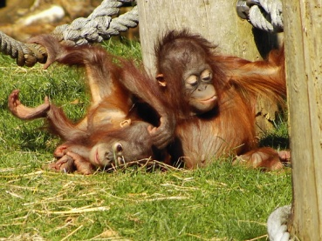**1)ANIMAL**

Name:

Species:

If available,add a picture of the animal before homeopathic treatment here and give it

a date and a name

Breed:

Sex: male / female /castrated

Date of birth: dd/mm/YYYY

Chip:

**2) OWNER**

First/last name:*Mr/Mrs

Country:

Address:*

Zipcode:* Town:*

**3) Previous Diagnosis / Treatment / Prognosis/** Veterinarian (if there was one)

Previous veterinarian: (if there was a previous treatment/diagnosis)

Name / title / specialization: *

Practice name / Institution: *

Country:

Address:*

Zipcode:* Town:*

Medical diagnoses and symptoms with dates:

Diagnostic methods (Attach files, lab results, x-ray, ultrasound, pictures ...):

Prognosis:

for life: hopeless – very doubtful - doubtful

for complete recovery: hopeless – very doubtful - doubtful

estimated time till death without therapy: ... weeks/month

Previous therapy (in detail):

|  |  |  |
| --- | --- | --- |
| Date  Start / end | Medications, Surgery, Diagnostics | Repetition, dosage |
|  |  |  |
|  |  |  |
|  |  |  |

Results of therapy: without any success /aggravated / better ...%

Euthanasia proposed. Yes/No

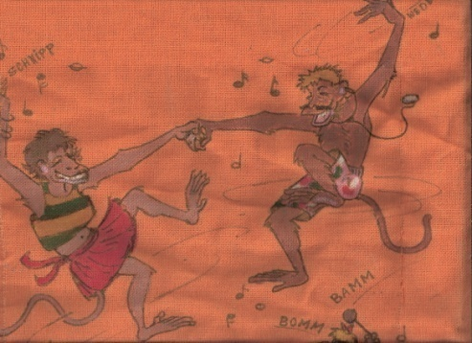**4)HOMEOPATHIC THERAPY**

First therapy date: dd/mm/yyyy

Homeopathic veterinarian: *

Name*, title, specialization:

Practice name / institution:*

Country:

If available add a picture

Of the animal after homeopathic

Treatment here.

Give it a date and a name

Address:*

Email:*

Phone:*

Medical diagnoses:

Homeopathic therapy classification: Constitutional / Local / Palliative

|  |  |  |
| --- | --- | --- |
| Date  Start / end | Remedy, potency, remedy form  (globules, dilution, pills, injection) | Repetition, dosage, route |
|  |  |  |
|  |  |  |
|  |  |  |

Additional therapies during homeopathic therapy:

Short homeopathic case presentation (not obligatory, max. 3 lines)

Repertorisation program: Radar / EH / Mac-rep / Other

Other method of case analysis:

Homeopathic therapy results:

Diagnostics: (Attach all high quality files, photos, lab, x-ray ...)

Classification of results: Cure / Palliation / Amelioration . . . % better

**5) Further Attachments**: (including: date and veterinarian !)

a)x-ray, ultrasound, lab result, veterinary report, pathological report, pictures from the period before and after **conventional treatment** should be attached here:

b) Further attachments: x-ray, ultrasound, lab result, veterinarian report, pathological report, pictures during & after the period of**homeopathic treatment** should be attached here:

**6) Special comments:**

*For example: the author has treated 12 similar cases of the disease (incurable cancer) with similar success. Or: the author has excellent success in homeopathic treatment of epileptic convulsions,or this kind of illness that is especially rare and / or difficult to treat.*

*Overwrite the examples or delete, please*

**7) The author confirms the validity of all presented information.**